CHANGES HISTORY
PIC | Date | Remarks
BJM.MR | 2018.04.19 | Created
Ghaida | 2018.04.19 | Created

TOC
- Analyst Quarter
- Analyst Field
- Analyst
- Financial Value
- Financial Data
- Estimate Eps
- Corporate File
- Quant Star
Diagram ENTITY RELATIONSHIP

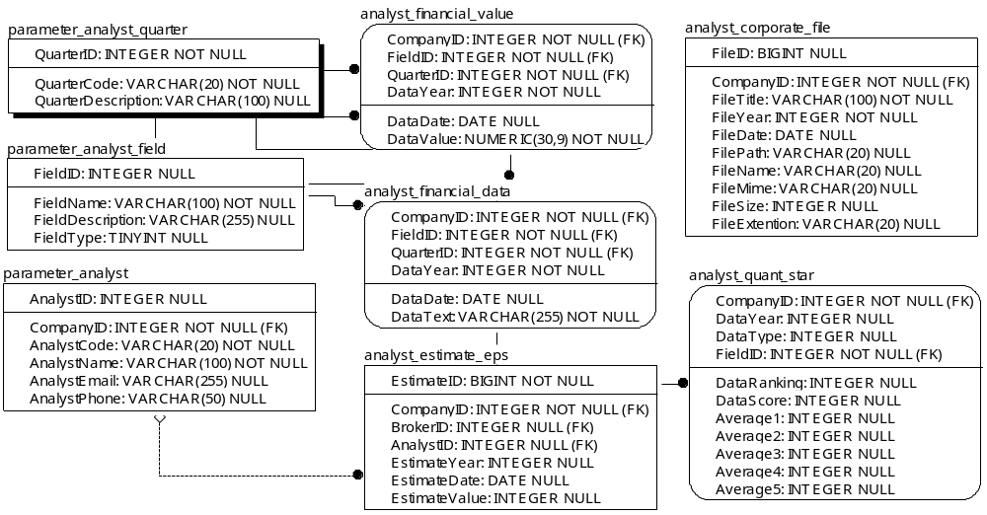
TABLE RELATIONSHIP
No | Table 1 | Table 2 | Type (1:1; 1:N; M:N) | Description
1. | parameter_analyst_quarter | analyst_financial_value
2. | parameter_analyst_field | analyst_financial_value
3. | parameter_analyst_quarter | analyst_financial_data
4. | parameter_analyst_field | analyst_quant_star
5. | parameter_analyst_field | analyst_financial_data
6. | parameter_analyst | analyst_estimate_eps

Name |  | parameter_analyst_quarter
Objective
No | Column |  | Type | Rule  (PK, FK, Key, NN, Unik, Index) | Description
1 | QuarterID |  | Integer | NN | Nomor id dari setiap company
2 | QuarterCode |  | Varchar(20) | NN
3 | QuarterDescription |  | Varchar(100) | Null

SAMPLE DATA
No | Column | Sample 1 | Sample 2 | Sample 3 | Sample 4
1 | QuarterID | 1 | 2 | 3 | 4
2 | QuarterCode | Q1 | Q2 | Q3 | Q4
3 | QuarterDescription | First Quarter | Second Quarter | Third Quarter | Fourth Quarter

Name |  | parameter_analyst_field
Objective
No | Column |  | Type | Rule  (PK, FK, Key, NN, Unik, Index) | Description
1. | FieldID |  | Integer | Null
2. | FieldName |  | Varchar(100) | NN
3. | FieldDescription |  | Varchar(255) | Null
4. | FieldType |  | TINYInteger | Null

SAMPLE DATA
No | Column | Sample 1 | Sample 2 | Sample 3 | Sample 4
1. | FieldID
2. | FieldName
3. | FieldDescription
4. | FieldType

Name |  | paremetet_analyst
Objective
No | Column |  | Type | Rule  (PK, FK, Key, NN, Unik, Index) | Description
1 | AnalystID |  | Integer | Null
2 | CompanyID |  | Integer | FK
3 | AnalystCode |  | Varchar(20) | NN
4 | AnalystName |  | Varchar(100) | NN
5 | AnalystEmail |  | Varchar(255) | Null
6 | AnalystPhone |  | Varchar(50) | Null

SAMPLE DATA
No | Column | Sample 1 | Sample 2 | Sample 3 | Sample 4
1. | AnalystID
2. | CompanyID
3. | AnalystCode
4. | AnalystName
5. | AnalystEmail
6. | AnalystPhone

Name |  | analyst_financial_value
Objective
No | Column |  | Type | Rule  (PK, FK, Key, NN, Unik, Index) | Description
1. | CompanyID |  | Integer | FK
2. | FieldID |  | Integer | FK
3. | QuarterID |  | Integer | FK
4. | DataYear |  | Integer | NN
5. | DataDate |  | Date | Null
6. | DataValue |  | Numeric(30,9) | NN

SAMPLE DATA
No | Column | Sample 1 | Sample 2 | Sample 3 | Sample 4
1. | CompanyID
2. | FieldID
3. | QuarterID
4. | DataYear
5. | DataDate
6. | DataValue

Name |  | analyst_financial_data
Objective
No | Column |  | Type | Rule  (PK, FK, Key, NN, Unik, Index) | Description
1. | CompanyID |  | Integer | FK
2. | FieldID |  | Integer | FK
3. | QuarterID |  | Integer | FK
4. | DataYear |  | Integer | NN
5. | DataDate |  | Date | Null
6. | DataText |  | Varchar(255) | NN

SAMPLE DATA
No | Column | Sample 1 | Sample 2 | Sample 3 | Sample 4
1. | CompanyID
2. | FieldID
3. | QuarterID
4. | DataYear
5. | DataDate
6. | DataText

Name |  | analyst_estimate_eps
Objective
No | Column |  | Type | Rule  (PK, FK, Key, NN, Unik, Index) | Description
1. | EstimateID |  | BIGInteger | NN
2. | CompanyID |  | Integer | FK
3. | BrokerID |  | Integer | FK
4. | AnalystID |  | Integer | FK
5. | EstimateYear |  | Integer | Null
6. | EstimateDate |  | Date | Null
7. | EstimateValue |  | Integer | Null

SAMPLE DATA
No | Column | Sample 1 | Sample 2 | Sample 3 | Sample 4
1. | EstimateID
2. | CompanyID
3. | BrokerID
4. | AnalystID
5. | EstimateYear
6. | EstimateDate
7. | EstimateValue

Name |  | analyst_corporate_file
Objective
No | Column |  | Type | Rule  (PK, FK, Key, NN, Unik, Index) | Description
1. | FIleID |  | BIGInteger | NN
2. | CompanyID |  | Integer | FK
3. | FileTitle |  | Varchar(100) | NN
4. | FileYear |  | Integer | NN
5. | FileDate |  | Date | Null
6. | FilePath |  | Varchar(20) | Null
7. | FileName |  | Varchar(20) | Null
8. | FileMime |  | Varchar(20) | Null
9. | FileSize |  | Integer | Null
10. | FileExtention |  | Varchar(20) | Null

SAMPLE DATA
No | Column | Sample 1 | Sample 2 | Sample 3 | Sample 4
1. | FIleID
2. | CompanyID
3. | FileTitle
4. | FileYear
5. | FileDate
6. | FilePath
7. | FileName
8. | FileMime
9. | FileSize
10. | FileExtention

Name |  | analyst_quant_star
Objective
No | Column |  | Type | Rule  (PK, FK, Key, NN, Unik, Index) | Description
1. | CompanyID |  | Integer | FK
2. | DataYear |  | Integer | Null
3. | DataType |  | Integer | Null
4. | FieldID |  | Integer | FK
5. | DataRangking |  | Integer | Null
6. | DataScore |  | Integer | Null
7. | Avarage1 |  | Integer | Null
8. | Avarage2 |  | Integer | Null
9. | Avarage3 |  | Integer | Null
10. | Avarage4 |  | Integer | Null
11. | Avarage5 |  | Integer | Null

SAMPLE DATA
No | Column | Sample 1 | Sample 2 | Sample 3 | Sample 4
1. | CompanyID
2. | DataYear
3. | DataType
4. | FieldID
5. | DataRangking
6. | DataScore
7. | Avarage1
8. | Avarage2
9. | Avarage3
10. | Avarage4
11. | Avarage5

